**ACTIVITY 1**

1. Open index.html on **Chrome**
2. Open the “**Elements**” tab of the developer’s tools (Ctrl + shift + I)

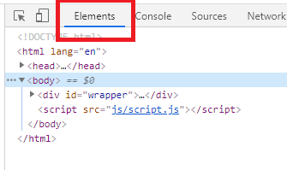

1. Answer the following questions and **return your word documents on telegram**:

Q1 – How many children has the element with id **add-book**?

In the element id add-book has 2 children

Q2 – What is the **parent** of the element h2 “book to read”?

The parent of the element h2 book is book-list

Q3 – What are the ID and CLASS of element used for?

We used id and class for easy called to display style on JS and CSS

+ Id (is Unit) has 6 used for add-book, book-list,

+ Class has 10 used for title, name, span

Q4 – Select the <div> of id “book-list” and delete it. What happens?

The happens is the text “book to read” go to left or don’t padding left